ARM VM ScaleSet using Portal

1. navigate to the [Azure portal](https://portal.azure.com) in a web browser. Click New, search for “scale set”, and then select the Virtual machine scale set

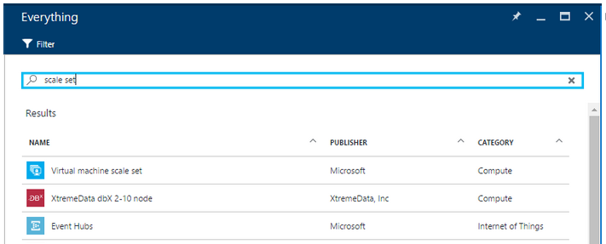

1. Click on “Virtual Machine Scale Set”. When new Blade opens, click on “Create”.
2. Enter info same as you’re creating a Virtual Machine. Scale Set name is a FQDN so it has to be unique globally.

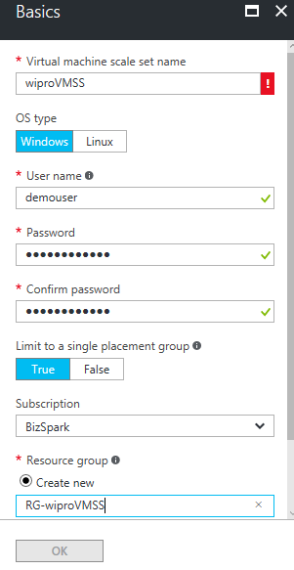

1. For information about selecting “False” in “Limit to a single placement group” please refer this link:

<https://docs.microsoft.com/en-us/azure/virtual-machine-scale-sets/virtual-machine-scale-sets-placement-groups>

1. On the Virtual machine scale set service settings blade: enter your desired domain name label

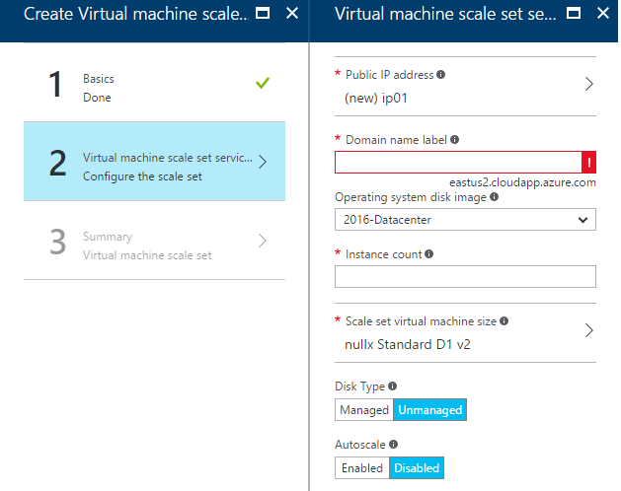

1. Click on OK. After verifying summary, click on OK again to start deployment.
2. You can connect to each VM in the scale set using these NAT rules. For instance, for a Windows scale set, if there is a NAT rule on incoming port 50000, you could connect to that machine via RDP on <load-balancer-ip-address>:50000

e.g. in this example, RDP will be - 52.163.112.222:50000

